FOR IMMEDIATE RELEASE Media Contacts:
Ania Kubicki or Tobin Ernst
ANGLES Communications
480-277-9245 or 480-322-8322
ania@anglespr.com or tobin@anglespr.com

First Tour of Allman Betts Band to Stop at Chandler Center for the Arts
Special Guest JD Simo to Open for Allman Brothers Band Progeny

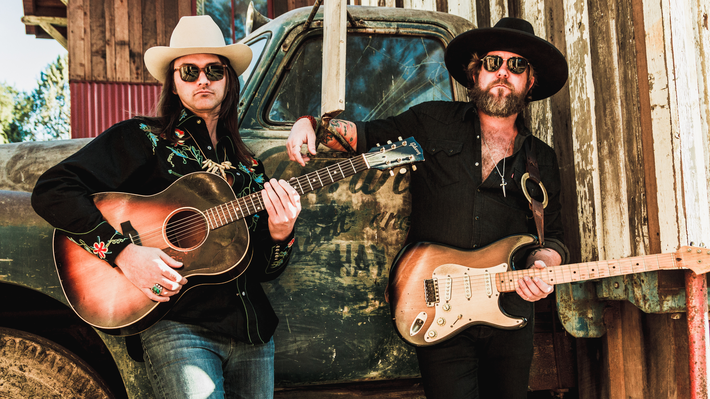

CHANDLER, Ariz. – [MARCH xx, 2019] — Devon Allman and Duane Betts, sons of the Allman Brothers Band royalty, have joined forces to form The Allman Betts Band and will perform at Chandler Center for the Arts on May 19 at 7 p.m. as part of their first world tour.

The tour follows a successful year touring together as The Devon Allman Project and marks a year of milestones for the Southern rock families, honoring the 50th anniversary of the Allman Brothers and the 30th anniversary of the younger Allman and Betts first playing together.

Ticket prices, ranging from $38 to $58, are on sale at www.chandlercenter.org, by calling 480-782-2680 or visiting the Chandler Center Box Office, located at 250 N. Arizona Ave.

Guitarist/singer Devon is the son of the late Allman Brothers Band co-founder Gregg Allman, and guitarist/singer Duane is the son of fellow Allmans co-founder Dickey Betts. The two met as boys during the Allman Brothers Band’s fabled 1989 reunion tour and have been friendly ever since, though never quite got around to playing together formally.

Over the past year, Devon and Duane shared the stage, collaborating and continuing their fathers’ legacies in their own way, playing a collaborative encore set that included inevitable Allmans classics like “Blue Sky” or “Midnight Rider,” but also songs from the likes of Tom Petty or the Grateful Dead or Prince. From those collaborations came the formation of the Allman Betts Band.

An extended family affair beyond the two, the new band also features bassist Berry Oakley Jr., the son of original Allmans bassist Berry Oakley. Along with Oakley are drummers/percussionists R. Scott Bryan and John Lum—both of whom played as part of Devon’s band. Slide guitarist Johnny Stachela, who played as part of Duane’s group, rounds out the lineup.

Together, The Allman Betts Band will release their first LP, “Down to the River,” later this year while performing more than 60 dates at festivals, theaters and historic venues.

Opening for the Allman Betts Band is psychedelic blues rocker JD Simo, who is promoting his first solo record, "Off at 11."

About Chandler Center for the Arts

The Chandler Center for the Arts is an engaging, welcoming, innovative space serving a diverse community. Located in the vibrant center of Downtown Chandler, it is a continually evolving location for all of us – using creativity and inspiration to bring people together through performances and exhibitions. Chandler Center for the Arts is a place that connects people - to our families, our friends, our cultural identity, to others and to ourselves.

For more information about programs, performances and exhibitions, go to chandlercenter.org.

###

CALENDAR LISTING INFORMATION
Event: The Allman Betts Band with special guest JD Simo
Date/Time: Sunday, May 19, 2019 @ 7:00 p.m.
Tickets: $38, $48 & $58
Venue: Chandler Center for the Arts
Venue Address: 250 North Arizona Avenue, Chandler, AZ 85225
Venue Website: www.chandlercenter.org
Artist Website: http://allmanbettsband.com
Box Office Phone: 480-782-2680
Twitter: http://twitter.com/chandlerarts
Facebook: http://www.facebook.com/ChandlerCenterfortheArts
Venue Contact: Cynde Cerf, Marketing & Communication Coordinator – Cynde.Cerf@chandleraz.gov
Phone: 480-782-2689

